U.S. Marine Corps Software Factory

Member Standards Handbook

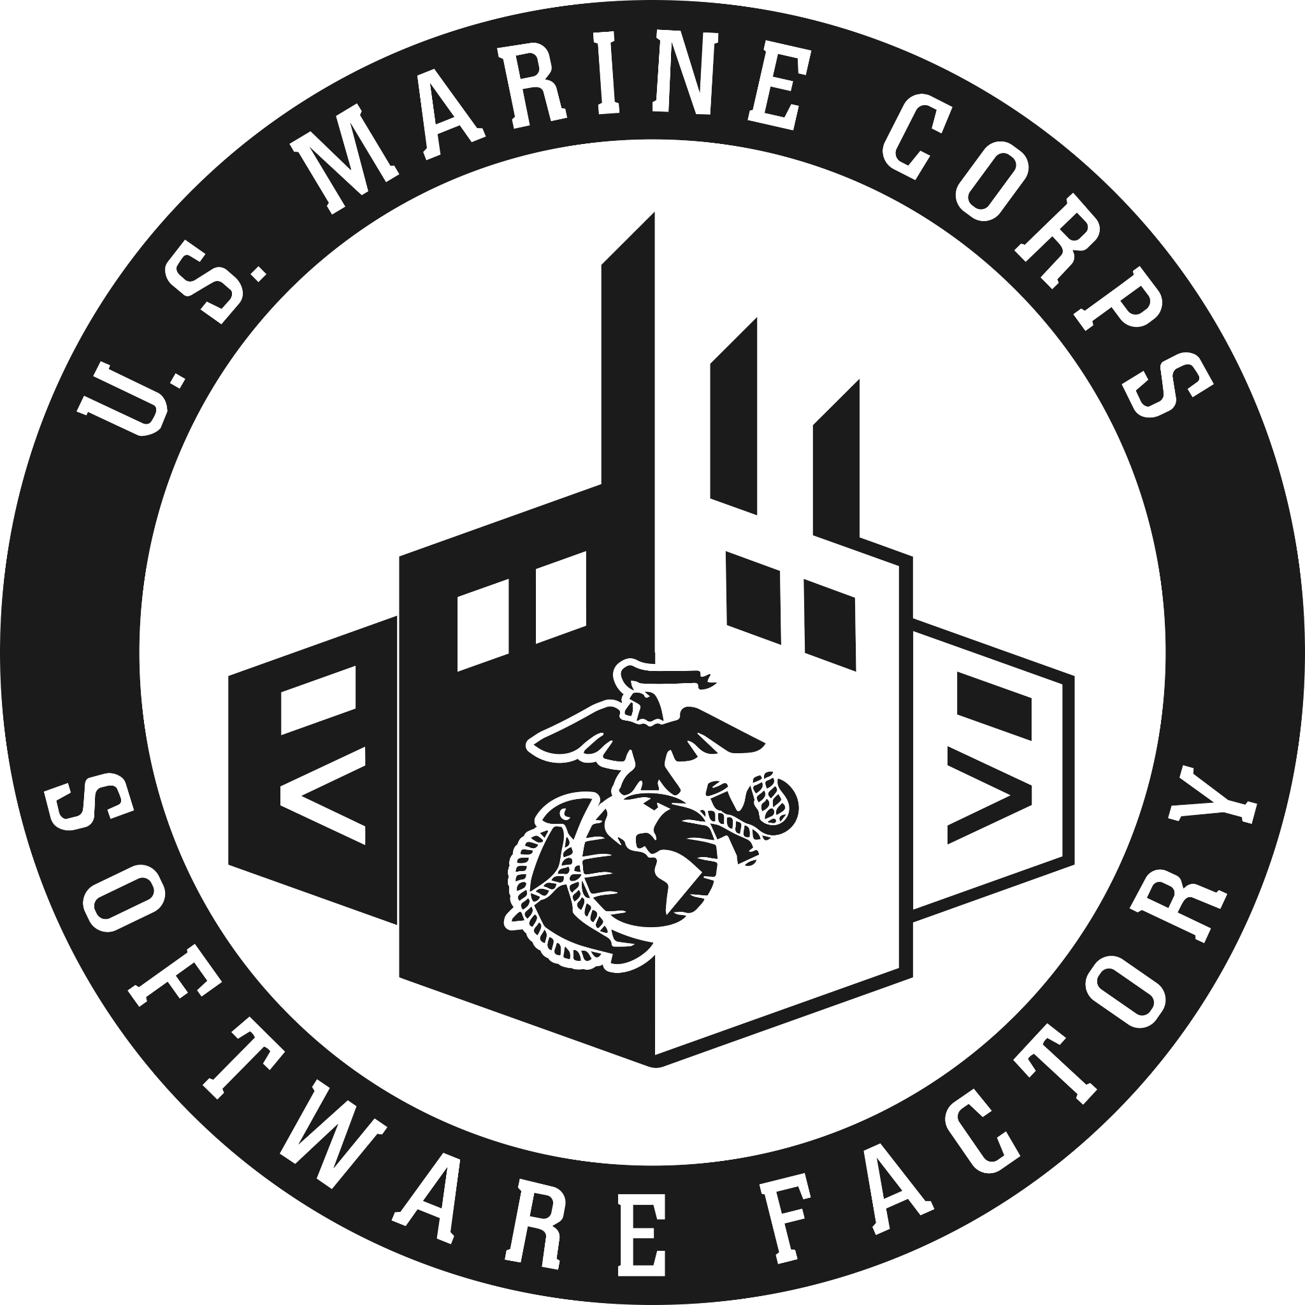
Updated: 20 Feb 2025

TABLE OF CONTENTS
In accordance with guidance provided by the Deputy Commandant for Information and Marine Corps Software Factory and informed by Marine Corps Regulations, the Marine Corps Software Factory has developed this Standards Handbook. This Standards Handbook applies to assigned and attached personnel of the Marine Corps Software Factory.

WELCOME LETTER 4
OUR VALUES 5
PURPOSE 5
MISSION 5
VISION 6
ENDSTATE 6
Marine Corps Software Factory (MCSWF) Code of Conduct 7
Conduct and Professionalism 7
Government vs. Contractor Personnel 7
Dos when working with contractors: 8
Don'ts when working with contractors: 9
Standards of Appearance 10
Civilian Attire Standards 11
Formal 11
Business Casual 11
Roughs 12
Physical Fitness and Medical Readiness Standards 13
Physical Fitness Requirements 13
PFT/CFT/PPFT/PCFT Failures 13
Administrative Actions 14
Retesting and Remediation 14
Marines are allowed to take multiple PFT/CFT/PPFT/PCFTs to improve their score during the current PFT/CFT season. Every official PFT/PPFT/CFT/PCFT taken will be entered into MCTIMS regardless of whether the score is higher, lower, or the same as previous attempts. Any PFT/CFT that is monitored by a properly assigned FFI/CPTR is considered an official PFT/CFT. 14
Individual Medical Readiness 14
Discipline, Academic Standards, and Release Policies 14
General Discipline 14
Accountability and Place of Duty 15
Academic Standards and Requirements 15
Behavioral Standards 16
Indicators for Program Dismissal: 16
Release and Dismissal Categories 16
Leave, Liberty, and Administrative Absence 17
Software Development Engineer What to Expect 18
Course Overview 18
Learning Outcomes 19
Instructional Methods 21
Assessments & Grading 21
Important Policies 21
Resources and Support 22
Product Manager/ Designer What to Expect 22
Course Overview 22
Learning Outcomes 24
Instructional Methods 25
Assessments & Grading 26
Important Policies 26
Resources and Support 27
Quick Reference Links 28

WELCOME LETTER
On behalf of the Marine Corps Software Factory, we extend our sincerest congratulations on your selection to the MCSWF. You are one of only 18 active-duty Marines chosen to demonstrate that this capability should be an organic part of our uniformed force. We are counting on you to help carry out our vision of expanding technological education and advancing the development of our Marines.
Becoming a member of the MCSWF is not just an achievement you should be proud of; it is a commitment to uphold the highest standards. Marines in the Software Factory will be held to a higher standard than average, with expectations that exceed those of many in the Fleet Marine Force (FMF). You will gain more exposure to the Marine Air-Ground Task Force (MAGTF) than most Marines. Through the training we provide and your extensive FMF exposure, your knowledge and experience will reach levels that few Marines will ever attain.
In our experience in the Marine Corps, we have witnessed the shift from analog systems to software-defined solutions. We believe this initiative represents the future of the IT community, regardless of MOS, and could potentially evolve into a new military occupational specialty altogether.
You, the new generation of Marines, are the driving force behind making this vision a permanent and sustainable capability for the Marine Corps.
Our motto is By Marines, For Marines.

Again, welcome to the Marine Corps Software Factory. You will find your time here personally challenging and professionally rewarding!

Major Will Oblak
MCSWF Director

Master Sergeant Jeff Averette
MCSWF Senior Enlisted Advisor

// OUR VALUES ●

- Innovation: Embrace and drive continuous improvement in software development methodologies and technologies.

- Collaboration: Foster a culture of partnership and open communication across all levels and stakeholders.

- Excellence: Strive for the highest standards in software development and delivery, ensuring robust, reliable, and user-centric solutions.

- Integrity: Maintain the highest ethical standards in all aspects of operations, earning the trust and confidence of all stakeholders.

// PURPOSE ●
The Marine Corps Software Factory Standards (MCSWF) Handbook provides Marines and Staff with a one-source document that clearly defines the standards of appearance, conduct, and military customs and courtesy. The Marine Corps Software Factory standards are an enforcement and enhancement of Marine Corps standards and orders. These standards will never violate Marine Corps standards or common expectations for conduct, appearance, and military bearing. The Deputy Commandant for Information and the Marine Corps Software Factory will continue to lead the way in the development, establishment and enforcement of standards. Due to the unique nature of our mission, this is a living, breathing document and the Marine Corps Software Factory leadership team reserves the right to change or adjust this document as our organization matures.

// MISSION ●
Create a World-Class, Marine-led, Mission-Specific Software Development Capability. Enable Marine modernization efforts by developing applications for commanders at the speed of operations to increase the operating force’s lethality and the supporting establishment’s efficiency & effectiveness.

// VISION ●
MCSWF vision is to have an institutionalized Marine-led software development capability, complete with full career paths in a new occupational field, that revolutionizes how the Marine Corps operates in the digital domain. MCSWF will become the premier upskilling organization for software development within the Marine Corps and, through partnership with other services and industry, a model for the broader DoD. Through a centralized C2 organization at MCSWF HQ, supported by Data Warfare Platoons at the tactical edge, we will deliver trained Marines capable of producing innovative, mission-focused software solutions, incorporating cutting-edge commercial technology, data science, and AI, that enhance command and control, optimize processes, and accelerate operational efficiencies across all warfighting functions. The modern battlefield exists over thousands of miles and across multiple domains. MCSWF will address these challenges by supplying commanders with fully trained software Marines fully enabling them to “locate, close with, and destroy” the enemy.

// ENDSTATE ●

The Marine Corps possesses a scalable organic capability enabling autonomous Marine-led teams that scope and engineer Marine Corps-wide software solutions

Marine Corps Software Factory (MCSWF) Code of Conduct
Marines selected to serve at MCSWF are expected to demonstrate professional and mature behavior at all times, both on and off duty. The following sections outline the policies on conduct, expectations, and the various forms of release or dismissal from the program.

Conduct and Professionalism
Marines are required to maintain law-abiding conduct in accordance with local, state, and federal laws, as well as the Uniform Code of Military Justice (UCMJ), Department of Defense (DoD) regulations, Marine Corps policies, and MCSWF guidelines. All Marines are expected to:
- Uphold the standards of the MCSWF Handbook, which provides guidance for appropriate actions in all situations.
- Take responsibility for personal conduct, as it contributes to the overall discipline and order of the unit.
- Communicate respectfully, addressing others appropriately by rank and name. Civilian and contractor personnel should be addressed as "Sir" or "Ma'am" unless directed otherwise.
- Be punctual and prepared for all meetings, whether in person or virtual. During virtual interactions, cameras should be on to enhance communication and emotional intelligence, unless circumstances (such as bandwidth limitations) dictate otherwise.

Government vs. Contractor Personnel
The following guidelines are provided within the Defense Acquisitions University, Contracting Officer's Representative training.
Civilian/General Schedule/GS
The government is required to obtain its employees by direct hire under competitive appointment or other procedures required by civil service laws. Government personnel are employees of the government that are hired, fired, supervised and rewarded by the government.
Contractor/CTR
Contractor personnel are employees of a contractor and are subject to the terms and conditions of their individual contracts with their employer and the applicable terms and conditions of their employer's contract with the government.
Inherently Governmental Functions
A contractor is prohibited from performing specific functions that are inherently governmental FAR 7.503. Only government officials can legally perform "inherently governmental functions" because they are so intimately related to public interest.
Inherently governmental functions involve:
- Direction/ control of federal employees
- Determination of budget policy, guidance and strategy
- Resource allocation or program management duties
- Approval of contractual documents or administering contracts
- Obligating congressional authorized funding

Dos when working with contractors:
- Respect the employer-employee relationship between contractors and their employees.
- Protect intellectual property rights when contractor work products are created or shared in the federal workplace.
- Identify possible conflicts by contractor personnel to include violations of the law. Be sensitive to inappropriate appearances created by close relationships between government employees and Seek assistance from legal counsel when resolving these inappropriate relationships.
- Safeguard sensitive information, including proprietary, Privacy Act, and source selection information.
- Clearly describe all contract tasks and ensure they are in-scope.
- Maintain contact with on-site contractor personnel in order to assess performance and ascertain progress or delivery status. In an Integrated Process Team (JPT) environment, closer working relationships are needed; however, ensure only the contractor's task leader assigns tasks to individual contractor personnel.
- Look at your situation from the contractor and contractor employee perspective. Are you putting the employee in a difficult situation by asking for performance above or outside the contract? Does your interaction with contractor personnel give the perception of favoritism?
- Be aware of foreign disclosure limitations when working with international partners.

Don'ts when working with contractors:
- Don't become involved in the operations and policies of the contractor such as:
- Selecting, recruiting, hiring, or firing contractor personnel.
- Directing, scheduling, or critiquing individual contractor tasks on a continuous basis .
- Supervising contractor personnel.
- Pressuring the contractor to use "favorite" personnel, or insisting on particular personnel actions.
- Don't use government and contractor personnel interchangeably.
- Don’t require "out of scope" work, personal services, or "inherently governmental functions" as there are no "and other duties as assigned" in the contract.
- Don't give incumbent contractors unfair advantage by allowing access to meetings/ information regarding re-competition.
- Don't solicit or accept gifts from contractor personnel (other than coffee, small food items, etc. in accordance with ethics regulations).
- Don't encourage contractor personnel to leave their workplace to attend a morale building activity, ask them to volunteer to organize morale building events, or participate in office gift giving, funds, etc.
- Don't give only one contractor authorized/ legally releasable information that may be of commercial value. If you share it with one, you must share it with all.

Standards of Appearance
Marines are also required to comply with MCO 6110.3A W/CH-3, the Marine Corps Body Composition and Military Appearance Program (MCBCMAP). Marines who do not meet height and weight standards, have a poor military appearance, or fail to comply with the MCBCMAP may be assigned to the Body Composition Program (BCP) or Military Appearance Program (MAP). Administrative actions will be taken according to MCO 6110.3A W/CH-3 for failure to maintain these standards.
In addition to this guidance, MCSWF enforces strict dress and professional behavioral guidelines to ensure a polished and professional image, even in a non-standard operating environment:
- Marines working at Innovation Tower are allowed to wear civilian clothing per MCO 1020.34H, the Marine Corps Uniform Regulations. However, the Marine Corps Combat Utility Uniform (MCCUU) in woodland Marine Pattern (MARPAT) is required every Monday or the first workday following a liberty period, with grooming standards strictly enforced.
- Any violations of the uniform or grooming regulations will result in administrative actions.
- The privilege of wearing civilian attire can be revoked if infractions occur, with the potential consequence of requiring daily wear of the seasonal service uniform.

Civilian Attire Standards
When permitted to wear civilian attire, MCSWF personnel are expected to maintain a professional appearance at all times. Across the DoD, three generally accepted levels of dress for official military business include Formal, Business Casual, and Rough. Daily attire at MCSWF is Business Casual, unless directed otherwise. Regardless of the level, clothing must be clean, well-fitted, and in good condition. Torn, faded, or excessively worn clothing is prohibited. In the absence of specific guidance, Marines should use situational awareness to determine the appropriate level of dress.

Marines should familiarize themselves with the following examples of each type:

Formal
The most formal civilian clothing type. They are essentially business attire (suit, tie, and
dress shoes) used for official or formal occasions such as meetings with high ranking officials of both the U.S. and Host Nation.

Formal attire consists of:

Males
- Slacks
- Button-up shirt with collar
- Blazer or suit coat
- Dress shoes (complimentary to the attire)
- Belt and socks (complimentary to the attire)
- Ties may be worn if required
- An all-weather jacket or overcoat may be worn and is optional
- Hats will not be worn

Females
- Dress
- Slacks or conservative skirt
- Button-up blouse or equivalent
- Blazer or suit coat
- Dress shoes should be conservative and complementary to the attire
- Belt, stockings or socks will be worn as necessary
- Fleece or all-weather jacket (non-military) may be worn and is optional
- Jewelry may be worn as long as it is conservative and complementary to the attire
- A handbag may be carried as long as it complements the attire and the situation is suitable

Business Casual
Less formal than formal attire, yet still present a professional appearance
(collared shirt, slacks, and possibly a jacket, jeans). Business casuals can be used for day-to-day activities when the culture does not require formal attire.

Business Casual attire consists of:

Males
- Slacks
- Jeans, with no holes or tears
- Button-up shirt with collar
- Shoes (complimentary to the attire)
- Belt and socks (complimentary to the attire)
- Ties may be worn if required
- Fleece or all-weather jacket (non-military) may be worn and is optional
- Hats will not be worn

Females
- Slacks or conservative skirt or dress
- Button-up blouse or equivalent
- Dress shoes should be conservative and complementary to the attire
- Belt, stockings or socks will be worn as necessary
- Fleece or all-weather jacket (non-military) may be worn and is optional
- Jewelry may be worn as long as it is conservative and complementary to the attire and within regulations stated in MCO 1020.34H
- A handbag may be carried as long as it complements the attire and the situation is suitable

Roughs
This is the least formal civilian clothing type. They are intended for use when conducting
missions that require more hearty clothing to withstand a more physically rugged environment and activity. Roughs include shirts with a collar, heavy denim pants, cold or wet weather tops and bottoms, and boots.

Rough attire consists of:

Males
- Cargo pants or tasteful jeans
- Collared shirt (Polo or equivalent)
- Fleece or all-weather jacket (non-military) may be worn and is optional
- Hiking boots or equivalent
- Belt and socks (complimentary to the attire)
- Hats may be worn on a case by case basis

Females
- Same as males except the shirt may be substituted for a tasteful blouse (no spaghetti straps, tank-tops or un-tasteful exposure of skin)

Do’s
- When direct guidance is not available, use good situational awareness to determine the appropriate dress code. Dress for the situation.
- When TAD, pack extras. Laundry service may not be available.
- Remember that you are a professional, whether in civilian attire or uniform.
- Consider cultural norms when choosing attire.

Don'ts
- Mistake civilian attire for “street” attire. Civilian attire is not a pass to express your individuality.
- Overdress. Remember that even though you are in civilian attire, you have a job to do.
- Do not wear tank tops, crop tops, and low-cut or revealing tops.
- Dresses/Skirts must cover the knees AT ALL TIMES, including walking, sitting, and standing.
- Hoodies are generally not authorized unless they are Marine affiliated.

Physical Fitness and Medical Readiness Standards

Physical Fitness Requirements
Marines assigned to the MCSWF must meet the physical readiness standards as outlined in MCO 6100.13A, which includes successful completion of the Physical Fitness Test (PFT) or Partial Physical Fitness Test (PPFT), Combat Fitness Test (CFT) or Partial Combat Fitness Test (PCFT) annually. Failure to meet these standards will have administrative and professional consequences, as detailed below:

PFT/CFT/PPFT/PCFT Failures
Failure to pass any PFT, CFT, PPFT, or PCFT during the testing period will result in an adverse fitness report, impact proficiency marks, and place the Marine in a promotion restriction status until the test is passed. Additional administrative consequences include a required Page 11 or 6105 counseling entry, in accordance with MCO 6100.13A and related references for enlisted personnel and officers.

Administrative Actions
If a Marine fails consecutive PFTs/PPFTs or CFTs/PCFTs (outside of multiple attempts within the same semi-annual reporting period), they will be considered for administrative separation, per MCO 6100.13A. For example, if a Marine fails a PFT and a CFT within the same year, they will not immediately be considered for administrative separation. However, if the Marine fails either test in the following year, they will be subject to separation proceedings. Likewise, if a Marine passes a subsequent test following a failure, but then fails the same test in the next year, they will still be considered for separation.

Retesting and Remediation

Marines are allowed to take multiple PFT/CFT/PPFT/PCFTs to improve their score during the current PFT/CFT season. Every official PFT/PPFT/CFT/PCFT taken will be entered into MCTIMS regardless of whether the score is higher, lower, or the same as previous attempts. Any PFT/CFT that is monitored by a properly assigned FFI/CPTR is considered an official PFT/CFT.

Individual Medical Readiness
Marines are expected to remain healthy and prepared for duty at all times. It is every Marine's responsibility to maintain medical readiness. The MCSWF SEA is responsible for monitoring all Marines’ readiness in compliance by distributing monthly notifications. Any issues utilizing or enrolling in TRICARE or TRICARE Remote due to our Austin-based location should be raised to the Senior Enlisted Advisor immediately. This includes enrollment of dependents.

Discipline, Academic Standards, and Release Policies

General Discipline
The Marine Corps Software Factory (MCSWF) is committed to fostering a professional environment that promotes creativity, freedom of expression, and diversity. To maintain this environment, we employ adaptive, intuitive, responsive, and decisive measures:
- Adaptive: We use internal measures to track performance, attendance, and minor infractions. Evaluations addressing these issues are documented monthly or quarterly. Persistent issues will be reviewed by MCSWF leadership, potentially resulting in dismissal.
- Intuitive: Policies and procedures will proactively adjust to ensure fair opportunities for improvement. While the standards remain constant, mission parameters and external factors will be continually reassessed.
- Responsive: Immediate actions will be taken for infractions that compromise mission readiness, viability, or security. Non-compliance will be addressed without delay.
- Decisive: Recommendations for removal or disciplinary actions will be made justly and acted upon swiftly.
Marines who fail to uphold MCSWF values or Marine Corps standards will face administrative or disciplinary actions, which may include removal from the program or Uniform Code of Military Justice (UCMJ) action.

Accountability and Place of Duty
- Operation Hours: MCSWF operates from 0830 to 1730, with accountability being our top priority. Staff Function Leads and Team Leads must ensure 100% accountability to the MCSWF Operations Office no later than 0930 daily.
- Unaccounted Marines: Any Marine not accounted for will be reported immediately to the Marine Corps Software Factory Senior Enlisted Advisor (SEA). The SEA will attempt to contact all identified no-shows and continue efforts until each Marine is positively accounted for. Team Leads will document infractions and forward this documentation to be placed in the Marine’s Personnel File.
- Place of Duty: Marines are required to conduct all operations at the Marine Corps Software Factory located at Innovation Tower in downtown Austin unless otherwise specified. Virtual or remote operations may be authorized on a case-by-case basis with leadership approval and should not be assumed as an entitlement.
- Accountability Procedures for Operational Teams: The senior Marine of each product team must provide the SEA with daily accountability no later than 0845 on all normal working days. On days following a 72-hour or 96-hour liberty period, accountability is due no later than 0830.
- Accountability Procedures for Technical Accelerator:
  - Individuals will report to the senior Marine of their cohort prior to 0830.
  - The senior Marine will consolidate any anomalies or special circumstances and report the status for all cohort members to the SEA no later than 0845.

Academic Standards and Requirements
MCSWF supports the academic success of every Marine by setting clear standards and providing necessary resources:
- Competency Requirements: Marines must demonstrate proficiency through various assessments, including homework, practical exercises, written exams, and performance evaluations. Attendance in all classes and training activities is mandatory.
- Remediation and Assessment: Marines who score below 70 in any course within the University of Texas Technical Accelerator Program will undergo remedial training. A designated representative, appointed by the SEA, will determine if the Marine is fit to graduate or proceed to the operational phase.
- Dismissal Consideration: If a Marine fails to achieve a score of 70 or higher in more than one course, the SEA will recommend dismissal from the program. Dismissal may also result from disciplinary infractions, lack of motivation, or inability to adapt to the program's environment.
- Performance Evaluation: Marines are evaluated using the “Practice, People, Profession” methodology, which distinguishes technical skills, interpersonal abilities, decision-making, and adherence to MCSWF values. Continuous reassessment ensures Marines have the support needed for success.

Behavioral Standards
Behavioral infractions will be documented in performance reviews and addressed through counseling. Persistent issues will be escalated to MCSWF leadership and may result in dismissal. Violations impacting mission readiness, security, or viability will be addressed immediately and may lead to UCMJ action.

Indicators for Program Dismissal:
Continuous poor judgment, immaturity, failure to adapt to the program's culture and expectations, or inability to maintain financial stability are clear indicators that a Marine may be unsuitable for the program. These factors will be carefully reviewed to determine if dismissal is warranted.

Release and Dismissal Categories
Releases from MCSWF are categorized as administrative, academic, or disciplinary and are determined on a case-by-case basis:
- Administrative Release: Granted for reasons beyond the Marine's control. These are not considered adverse, and the Marine may reapply to a future cohort once the situation is resolved.
- Academic Release: Recommended when a Marine consistently fails to meet course standards despite reassessment attempts. Documented through the Marine’s Skills Matrix and noted their profile. Academic releases are not adverse but may prevent re-enrollment for a second time.
- Disciplinary Release: Considered adverse and based on violations of regulations, policies, or standards of conduct. Marines dismissed for disciplinary reasons will not be eligible to return to MCSWF and may face further consequences, including barring from reenlistment or non-judicial punishment. Causes include:
  - Negative attitude or lack of motivation disrupting the cohort.
  - Conviction under UCMJ or civilian court (excluding minor traffic violations).
  - Excessive absenteeism (more than 104 hours/13 days in Phase 1 or Phase 2).
  - Habitual misconduct (two or more adverse counseling sessions or spot reports).
  - Unsafe actions endangering the Marine or others.

Leave, Liberty, and Administrative Absence
In addition to the guidance set forth by MCO 6110.3 W/CH-3, Regulations for Leave, Liberty, and Administrative Absence, leave will not be granted while a Marine is in student status. A Marine is considered in student status while attending the Technical Accelerator and/or during the 1:1 SME pairing phase.
- Standard Leave: Leave can be taken during standard block leave periods (e.g., winter holidays and 4th of July) and all federal holidays with MCSWF staff approval.
- Case-by-Case Leave: Leave requests during the Technical Accelerator or 1:1 SME pairing will be processed on a case-by-case basis.
All leave, liberty, and administrative absences will be processed, approved, or denied in accordance with MCO 6110.3A.

Software Development Engineer What to Expect
The Software Development Engineer technical training consists of essentials in the areas of CLI, Pair Programming, Java Fundamentals, Object Oriented Programming, Test Driven Development, Databases, Javascript Fundamentals, Asynchronous Code, HTML & CSS, React, Agile, Docker, Deployment, Injection,Broken Authentication, Sensitive Data Exposure, Security Misconfiguration, Cross-Site Scripting XSS, Insecure Deserialization, Using Components with Known Vulnerabilities, Evolutionary Architecture, Test First Development (TDD), Containerizing Applications, Manual and AutomaticScaling, Liveness Probes, and Continuous Delivery / Integration.

The Software Development Engineer course, prepares students for Software
Development Engineer positions on a balanced product team focused on software
development. This course provides the knowledge and skills to design a product from an
engineering perspective and to program the associated software solution.

Course Overview
This course introduces the fundamental concepts of structured programming using a high-level language (such as Python).
Expect to learn about:
Database Design and Management:
- Designing, implementing, and maintaining databases.
- The Relational Database Model and the SQL language.
- Online Transaction Processing (OLTP) Systems and their comparison to Distributed Database Management Systems and Data Warehousing Systems.
- Web databases and their applications.
- Using the Oracle DBMS in lectures and labs.
Project Management:
- Project management best practices, objectives, processes, tools, and techniques.
- Managing project integration, scope, time, cost, and quality.
- Human resource, communications, risk, and procurement management in a project context.
- Completing projects through teamwork, scheduling, and the use of presentation, writing, and communication skills.
- Analyzing real project cases, developing plans, reports, and financials.
- Summarizing and evaluating project and team performance using project management principles.
Object-Oriented Programming with Java:
- Writing, testing, and debugging intermediate-level Object-Oriented programs using Java.
- Developing appropriate data models and database schemas.
- Creating and testing prototypes.
- Identifying subsystems and interfaces, and validating design schemes and models.
- Writing code, performing unit testing, and integrating subsystems.
- Resolving defects and adapting existing code.
- Defining system and software requirements, developing test requirements, and performing tests.
- Testing and validating programs using developed test procedures.
Advanced Web Authoring:
- Using advanced applications for web authoring, including Perl Scripts, Common Gateway Interface (CGI), Database Interaction, and Active Server Pages (ASP).
- Creating progressively complex websites incorporating HTML, CSS, JavaScript, PHP, and MySQL.
- Exploring ASP.NET caching, web services, and configuration topics.
- Using web development technologies to enhance user interaction and functionality.
Introduction to HTML, CSS, and JavaScript:
- Learning HTML, XHTML, DHTML, CSS, and JavaScript.
- Understanding data types such as integers, floats, and strings.
- Creating hyperlinks, images, lists, tables, forms, and cascading style sheets (CSS).
- Applying debugging techniques to web development.
- Using Object-Oriented Programming and control structures (selection and looping) in JavaScript.
- Working with arrays and the Document Object Model (DOM).

Learning Outcomes
By the end of this course, you will be able to:
Database Development and SQL:
- Recognize the basic concepts involved in the analysis and design of a database.
- Summarize the process of database development and administration using SQL.
- Enhance programming and software engineering skills with SQL.
- Develop an understanding of the technical support background necessary for SQL applications.
- Solve database problems using MySQL by applying SQL commands to create, insert, update, and retrieve data from a simple database.
- Recognize the services provided by a Database Management System (DBMS).
- Understand and apply the Relational Database Model.
- Recognize transaction processing and multi-user database support.
- Differentiate between production transaction databases and data warehouses.
- Recognize the client/server architecture used in DBMS.
- Design and implement a basic database solution using MySQL.
Web Development with HTML and JavaScript:
- Learn HTML tags and JavaScript programming concepts and techniques.
- Develop the ability to logically plan and develop web pages.
- Write, test, and debug web pages using HTML and JavaScript.
- Write scripts using JavaScript to support web page functionality.
- Incorporate JavaScript effectively in web pages.
- Create forms and validate data accuracy.
- Use JavaScript system objects and embed objects in web pages.
- Implement decision and looping statements in JavaScript.
- Manipulate strings and use array processing effectively in JavaScript.
Intermediate-Level Web Development:
- Build progressively complex websites that incorporate HTML, CSS, JavaScript, PHP, and MySQL.
- Design, develop, and implement programs for web functionality.
- Write and perform unit testing on code.
- Integrate subsystems, resolve defects, and revise existing code.
- Test and validate programs, developing appropriate test procedures.
Object-Oriented Programming with Java:
- Write, test, and debug intermediate-level object-oriented programs in Java.
- Design and develop data models and database schemas.
- Create and test prototypes.
- Identify major subsystems and interfaces.
- Validate design schemes and models.
- Implement Java programs, perform unit testing, integrate subsystems, and resolve defects.
- Define system and software requirements, develop test requirements, and perform tests.
- Validate program functionality with developed test procedures.
Project Management Best Practices:
- Apply project management principles, objectives, processes, tools, and techniques.
- Complete projects requiring teamwork, meeting milestones, and using communication, writing, and presentation skills.
- Analyze real project cases, develop project documents (plans, reports, financials, etc.).
- Summarize and evaluate project and team performance using project management concepts.
- Gain hands-on experience with word processing, spreadsheets, PowerPoint, and Microsoft Project 2013.

Instructional Methods
This course will be divided equally between lectures and labs. Expect to spend half the class learning theory and the other half applying concepts through programming tasks. Coursework will be supported via Blackboard, where you’ll access materials like PowerPoints, assignments, and grades.

Assessments & Grading
- Exams: 3 exams, including a final, will assess your understanding of programming fundamentals.
- Quizzes/Practice Assignments: Weekly assessments will help reinforce concepts.
- Lab Assignments: Expect regular labs to apply what you've learned in a hands-on environment.
- Development Fridays Project: On Fridays, you'll work on a project to develop a Loan Calculator.
Grading Breakdown:
- Exams: 200 points (3 exams)
- Quizzes/Practice Assignments: 100 points
- Lab Assignments: 100 points
- Development Project: 100 points
Total: 500 points
Grades are assigned based on percentages: A (90%-100%), B (80%-89%), C (70%-79%), D (60%-69%), F (<59%).

Important Policies
- Attendance: Regular attendance is crucial. Missing classes or labs may result in being dropped from the course.
- Late Assignments: You have a two-day grace period for lab assignments with a 20% penalty.
- Withdrawal: It’s your responsibility to withdraw if necessary, and there may be financial or academic impacts. Be sure to meet deadlines.
- Incompletes: Only granted for serious extenuating circumstances and must be completed by a deadline set with the instructor.
- Scholastic Integrity: Plagiarism or any form of cheating will result in a grade of F.

Resources and Support
- Textbook: Starting Out with Python by Tony Gaddis (5th edition). Available online through Blackboard.
- Technology Support: Free WiFi is available on site, and you may qualify to check out an iPad for the semester.
- Student Support Services: UT provides services for academic help, tutoring, library access, and personal support, including counseling.

Product Manager/ Designer What to Expect
As a Product Manager/ Designer, you’ll play a crucial role in building successful software products that meet both user needs and business objectives. Whether you're new or experienced, the processes here are designed to help you thrive in a collaborative, user-centered, and agile environment.

Course Overview
This course provides a comprehensive exploration of essential concepts in product management and design, equipping participants with the knowledge and skills needed for success in dynamic, collaborative work environments. Through a structured curriculum, participants will engage with key learning objectives covering Product Management (PM) Basics, Design Basics, Principles of Visual and User Interface Design, Collaborative Leadership Skills, and Software proficiency.
Expect to learn about:
User Experience (UX) Design:
- The complexity of UX design practices, including storytelling, ideation, user research, and interaction design.
- Basics of information architecture, product strategy, and design best practices.
- Techniques for creating user-centered experiences and presenting design decisions.
- Intro to design ethics, accessibility (508/WCAG), and balanced team collaboration.
Design Ideation:
- Creative problem-solving processes like Human-Centered Design and Design Thinking.
- Sketching for visual thinking, storytelling, wireframing, and prototyping.
- Using sketching as a tool for idea generation and applying it to design challenges.
Product Design:
- The role of product design in business and understanding product life cycles.
- Research and validation techniques for product design.
- Setting and tracking metrics for product success.
- Public speaking, stakeholder communication, and team leadership skills.
UX Tools (Part 1):
- Industry-standard tools for prototyping, collaboration, and creating UI elements.
- Design Systems and their focus on design experiences and consistency.
- Techniques for building visual assets and collaborating effectively on design projects.
Design Research:
- Applying user research methods (generative and evaluative) for design decision-making.
- Conducting user interviews, usability testing, and analyzing research findings.
- Presenting data and design recommendations based on research outcomes.
Information Architecture:
- Organizing, categorizing, and labeling content, functions, and features for software products.
- Designing site structure, navigation systems, and search functionality to improve user experience.
Visual Design:
- Applying visual language to digital environments like websites and apps.
- Designing user interfaces using universal principles, typography, and color theory.
- Working with style guides, pattern libraries, and designing for variable content.
UI Design 1:
- Exploring UI design patterns for navigation, forms, data display, and feedback.
- Learning basics of wireframing, user flows, and annotating mockups.
UX Tools (Part 2):
- More advanced industry tools for building prototypes and collaboration.
- Creating UI elements and prototypes using design systems.
Interaction Design (IxD):
- Understanding the role of psychology in design, including cognition, perception, and memory.
- Designing and testing interactions that motivate user behavior.
UI Design 2:
- Advanced topics in UI design like micro-interactions, UX writing, and conversational interfaces.
- Effective communication for intuitive design.
Responsive Design:
- Essential coding skills for designers, including HTML, CSS, and Responsive Design techniques.
- Building websites from scratch and applying modern web design principles.
- Working with responsive design frameworks like Tailwind CSS.
Custom Topics:
- Additional concepts like data analysis, product vision, risk management, and stakeholder management.
- Backlog management, roadmaps, and prioritization for product design and development.
- Working with developers, stakeholders, and platform-specific design.

Learning Outcomes
By the end of this course, you will be able to:
Understand Product Management Basics:
- Gain a deep understanding of the role of product management within organizations and balanced teams.
- Learn Agile software design processes and Lean principles.
- Be familiar with essential frameworks such as Jobs to be Done, Story mapping, and Product Roadmaps.
- Understand the full lifecycle of a product, from conception to retirement, through real-world examples.
Master Design Basics:
- Apply user-centered design principles and the design thinking framework.
- Conduct user research and create affinity maps.
- Develop user personas and apply them in design processes.
- Create hypotheses and understand information architecture.
- Design wireframes, prototypes, and engage in iterative design based on user feedback.
Develop Visual and User Interface Design Skills:
- Understand typography and color theory for product design.
- Develop visual designs using mood boards and style tiles.
- Explore atomic design, grids, components, and design libraries.
Enhance Collaborative Leadership Skills:
- Develop collaborative leadership skills by comparing the Military Decision Making Process (MDMP) with the Double Diamond UX design framework.
- Practice sketchnoting and visual facilitation.
- Adhere to ethical standards in both user experience design and product management.
- Foster collaborative working relationships, practice responsible participation, and engage in creative problem-solving.
Gain Basic Software Skills:
- Become proficient in using Blackboard for course management.
- Acquire basic Mac skills.
- Use Figma to create application maps, wireframes, and high-fidelity mock-ups.

Instructional Methods
This course will be divided equally between lectures and labs. Expect to spend half the class learning theory and the other half applying concepts through programming tasks. Coursework will be supported via Blackboard, where you’ll access materials like PowerPoints, assignments, and grades.

Assessments & Grading
Grading Breakdown:
Assignments should be submitted in Blackboard as links to Google Drive documents. Feedback and grades will be given within 48-72 hours. Remember to focus on the feedback given versus a particular score.
- 0 – The assignment was not turned in. Late assignments will not be graded. Contact your professor in advance for alternatives if you believe you may miss an assignment deadline.
- 1 – Resubmit. The assignment shows a lack of foundational understanding with multiple areas for improvement.
- 2 – Resubmit. The assignment shows foundational understanding with some areas for improvement.
- 3 – Passed. The assignment shows foundational understanding and fulfills requirements. Students should consider feedback to ‘level up’.
- 4 – Good. The assignment shows a solid understanding and implementation of the concept.
- 5 – Exceeds. The assignment shows superior understanding and senior-level implementation of the concept.
Assignments will be graded and count towards qualification to move to the next phase. Unsatisfactory assignments may be resubmitted and need to be turned in no more than 72 hours later. Students may resubmit no more than twice per assignment. Excessive use of the resubmission policy may result in counseling, additional assignments, or required tutoring to ensure the student’s successful course completion.
Peer critique is required on certain assignments. Those assignments are marked in Blackboard and will be announced in class.

Important Policies
- Attendance: Regular attendance is crucial. Missing classes or labs may result in being dropped from the course.
- Late Assignments: You have a two-day grace period for lab assignments with a 20% penalty.
- Withdrawal: It’s your responsibility to withdraw if necessary, and there may be financial or academic impacts. Be sure to meet deadlines.
- Incompletes: Only granted for serious extenuating circumstances and must be completed by a deadline set with the instructor.
- Scholastic Integrity: Plagiarism or any form of cheating will result in a grade of F.
- Late assignments will not be graded. Contact your professor in advance for alternatives if you believe you may miss an assignment deadline.
- Presentations can be rescheduled in the case of illness or planned travel or medical appointments. Notify your professor in advance to make arrangements to deliver your presentation. Make-up presentations may be scheduled outside regular classroom hours, depending on the lesson plan for the week.
- Quizzes are a required part of your grade and are to be completed in person, in the classroom. If you have a commitment that has you off-campus during a quiz day, work with your professor to arrange a time during that day that you can take the quiz online. In case of illness, contact your professor as soon as possible to arrange for an alternative assessment activity.

Location & Onsite Information
- MCSWF Address:
  - Innovation Tower | 1300 Red River St, Floor 5, Ste. 540, Austin, TX 78701
  - Tenant & Visitor Parking Garage entrance is located on Red River
  - You will be issued a badge on your first day. This badge will grant you access to the parking garage, the gym (located on B1 level of the parking garage) and to our office space on the 5th floor, suite 540.
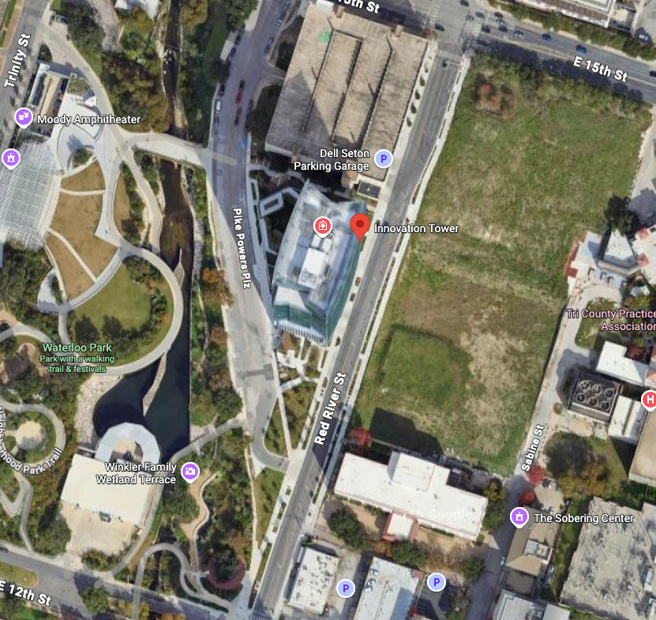

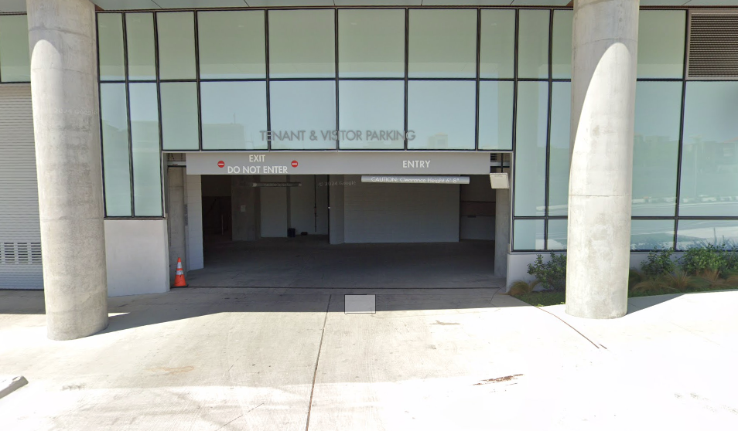
- Working Hours:
  - Based on your team’s agreement, 0730-1530 or 0830-1630
- Onsite Gym:
  - Located in the parking garage B1 level (1st level)
  - Lockers, showers, and towels available
  - Weight room, treadmills, stairmaster, pelatons, rowers, boxing bag, ellipticals
  - Badge access only
- Monthly Org Offsites:
  - Last Thursday of every month, we will as an organization have an offsite for team building
- Quarterly Org Family Events:
  - Every quarter, we will plan events open to family to attend
- MCSWF SWAG:
  - MarineCorpsSoftwareFactory.merchologysolutions.com
  - Let Amber know you submitted an order so she can keep track of the order

TAD Process & Approval
For more information, please refer to the TAD CONOPS SOP

- Complete a Mock DTS
  - Before drafting a CONOPS, the requesting Marine completes a Mock DTS to capture the 5 Ws and a realistic cost estimate. This is the source data for the CONOPS template. DO NOT submit into DTS before Director approval.
- Build and Submit the TAD CONOPS
  - Using the Mock DTS data, the requesting Marine completes the MCSWF TAD CONOPS Template (companion slide deck) and submits it to the Director NLT 30 calendar days before the travel start date.
- Director Review & Approval
  - The Director reviews the CONOPS and either approves or disapproves it, normally within 5 business days of receipt. A disapproved CONOPS is returned to the requester with the reason documented so it can be revised and resubmitted.
- Log to the SharePoint TAD Tracker
  - Once approved, the requesting Marine logs the trip in the MCSWF TAD Tracker within 2 business days, attaching or referencing the signed CONOPS.
- Submit in DTS
  - With the CONOPS approved and the Tracker updated, the requesting Marine completes the official travel authorization in DTS.

Resources and Support

Business & Agile Thinking:
- OUTCOMES OVER OUTPUT: Why Customer Behavior is the Key Metric for Business Success by Joshua Seiden (Sense & Respond Press)
- LEAN STARTUP: How Today's Entrepreneurs Use Continuous Innovation to Create Radically Successful Businesses by Eric Ries
Design Thinking:
- JUST ENOUGH RESEARCH by Erika Hall (A Book Apart)
- DESIGN OF EVERYDAY THINGS by Donald Norman
- 100 THINGS EVERY DESIGNER NEEDS TO KNOW ABOUT PEOPLE by Susan M. Weinschenk, Ph.D. (Pearson)
Software Development:
- EXTREME PROGRAMMING EXPLAINED by Kent Beck
- EVERYDAY INFORMATION ARCHITECTURE by Lisa Marie Martin (A Book Apart)
- STARTING OUT WITH PYTHON 5th edition by Tony Gaddis

We recommend starting here to build useful skills before you arrive at MCSWF:
- CS50x - Harvard Intro to Computer Science
- MIT Missing Semester – command line, Git, debugging, developer tools
- Learn Git Branching – interactive Git practice
- roadmap.sh – visual learning paths for technical careers

Software Engineering:
Pick one primary curriculum and work through it:

- Boot.dev
- The Odin Project
- MDN Web Development
- Full Stack Open

Topics to become familiar with:
- Python
- JavaScript/TypeScript
- React
- Git
- APIs
- SQL
- Testing
- CI/CD
- Docker
- Linux
- Basic Cybersecurity
- 508 Compliance

Quick Reference Links
Websites:
- Basic Allowance for Housing
  - MCSWF Zip Code: 78701
- For Our Troops | TxDMV.gov
- Great Schools
- Housing Research
- Military Families Center
- MCSWF Website
- MCSWF Linkedin
- For Our Troops | TxDMV.gov
- https://www.txdmv.gov/motorists/for-our-troops
- Child Care - Request voucher, get a case manager
- Daycare Voucher Application - submit application for voucher with daycare
- Great Schools
- Tricare
- Housing Research
- CapMetro Map
- Vet Tix

Locations:
- ID Cards: Building 34 DEERS ID Card Section | 2200 W 35th St, Austin, TX 78703
- YMCA: Townlake YMCA

Contacts

COL Pedro Ortiz

pedro.ortiz@usmc.mil

(267) 972-7299

Maj Will Oblak

william.t.oblak.mil@usmc.mil

(612) 803-9726

MSgt Jeff Averrette

jeffery.averette@usmc.mil

(760) 213-0916

Amber Slone - Program Manager
aslone@atxdefense.com
972-743-8773

